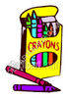
2nd Grade GES Supply List

Gramercy Elementary School
2015-16

1 – school bag
1 – pair of headphones or earbuds
1 – large bank bag with zipper
1 - jumbo Book Sock (to cover Reading book)
2 – composition notebooks (black & white marbled)
1 - 1 subject notebook (red)
1 – hard, PLASTIC YELLOW pocket folder
3 – hard, PLASTIC pocket folders (red, blue, and green)
4 – boxes of #2 plain sharpened pencils (24 pack please)
1 – Pair of Scissors
1 – large glue sticks
1 – box of 24 count crayons
1 – box of Kleenex
1 – roll of paper towels
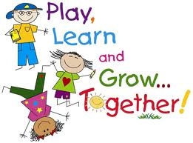
1 – box of quart-size Ziploc bags (girls only)
1 – box of gallon-size Ziploc bags (boys only)
1 – container of baby wipes (girls only)
1 – container of disinfecting wipes (boys only)

*Your child’s teacher may request additional supplies later in the school year. BINDERS, CLIPBOARDS, or BOXES are not allowed due to limited space in the students’ desks.

