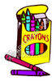
3rd Grade GES Supply List
Gramercy Elementary School

2015-2016

- 1 - Backpack /School Bag (Please no rolling school bags)
- 4 – Plastic folders (1 red, 1 blue, 1 yellow, 1 orange)
- 1 – Bank style zipper pouch
- 2 – 1 Subject Notebooks
- 1 – Pack of loose leaf paper
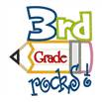
- 3 – Packs of # 2 pencils (NO lead pencils please)
- 2 - Packs of cap erasers
- 2 - Large glue sticks
- 1 – Pair of scissors
- 2 – Boxes of 24 count crayons
- 2- Boxes of 8 count markers
- 1 – Box of Kleenex
- 1 – Roll of paper towels
- 1 – Box of Ziploc bags (quart-sized)
- 1- Container of disinfecting wipes
- 1 - Pack of construction paper
- 1- Set of headphone

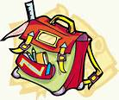

NO CLIPBOARDS OR BOXES ALLOWED!
Write your child’s name on all school supplies.

