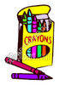
Gramercy Elementary School
4th Grade GES Supply List
2015-2016

To turn in:
2 plastic folders of any color (homework and graded papers)
1 plastic red folder (reading)
1 plastic yellow folder (social studies)
1 plastic green folder (science)
1 plastic blue folder (math)
1 plastic purple folder (ELA)
2 composition notebooks (Daily Start, Writing)
Headphones to keep at school for computer use
1 pack of loose leaf paper
1 box tissues
1 roll paper towels
1 box Ziploc bags (boys – quart size; girls – gallon size)
1 pack of baby wipes (girls)
1 pack of disinfecting wipes (boys)

To keep in book sack:
Glue stick
Scissors
2 packs of pencils (non-mechanical only)
Small personal pencil sharpener
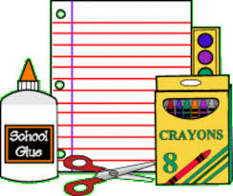
Crayons
Highlighters
Markers
Zippered pencil bag
2 one inch binders any color
1 pack of binder dividers

