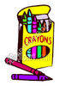
Pre-Kindergarten GES Supply List

Gramercy Elementary School
2015–2016

*1 school bag (no rolling school bags please)
*1 towel or small blanket for rest time
*1 1-inch rest mat (no sleeping bags or cloth mats please)
*1 extra set of school clothes (this does not have to be a uniform, must be a complete set- shirt, shorts, underwear and socks)
*1 pair of headphones (no earbuds please)
*1 pair of scissors (blunt tip)
*1 box of large size crayons
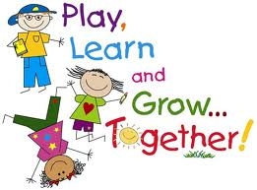
*1 box of regular crayons (16 count)
*1 8- or 10-pack of markers
*1 bottle of glue
*2 jumbo glue sticks
*1 1” binder
*1 plastic folder
1 pack of pencils
1 refill bag of baby wipes
1 container of disinfecting wipes
1 roll of paper towels
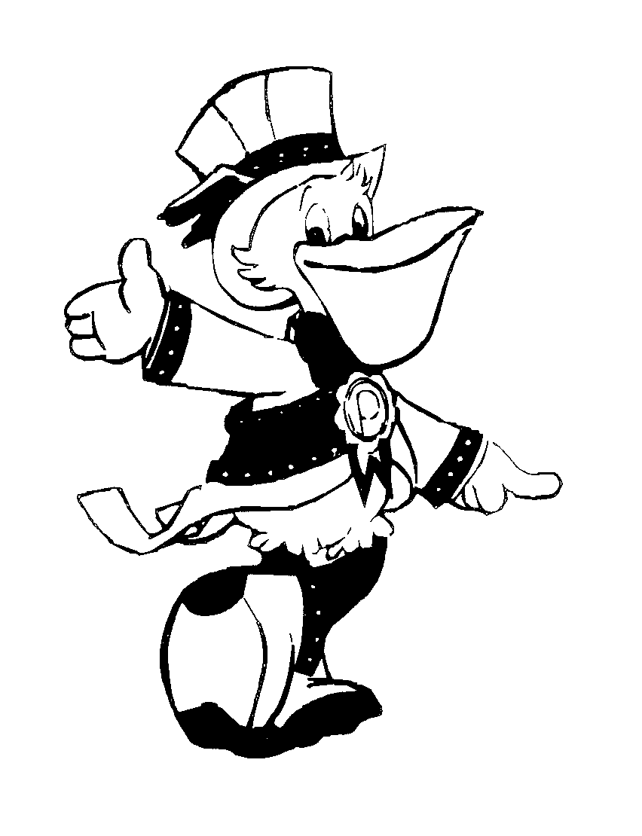
1 box of Kleenex
1 box of gallon size Ziploc bags (girls)
1 box of quart size Ziploc bags (boys)
1 pack of construction paper (no tablets please)

* = Please write your child’s name on this/these item(s).

